**Power scaling of diode-pumped Continuous-Wave Pr,Gd:CaF2 laser at 642 nm**

**Saiyu Luo, Xigun Yan, Bin Xu, Huiying Xu, Zhiping Cai1,*, Hao Yu2, Liangbi Su2,*, Dongzhen Li3, Xiaodong Xu3 and Jun Xu4**

*1. Department of Electronic Engineering, Xiamen University, Xiamen 361005, China*

*2. Synthetic Single Crystal Research Center, Shanghai Institute of Ceramics, Chinese Academy of Sciences, No.588 Heshuo Road, Shanghai 201899, China*

*3. Jiangsu Key Laboratory of Advanced Laser Materials and Devices, School of Physics and Electronic Engineering, Jiangsu Normal University, Xuzhou 221116, China*

*4. School of Physics Science and Engineering, Institute for Advanced Study, Tongji University, Shanghai 200092, China*

*\*E-mail:* [zpcai@xmu.edu.cn](mailto:zpcai@xmu.edu.cn), suliangbi@mail.sic.ac.cn

**Abstract:** Based on a double-end pumping geometry, we demonstrate a power scaled laser operation of room-temperature continuous-wave red laser at 642 nm in Pr3+:CaF2 crystal codoped with Gd3+. A maximum output power of ~70 mW with a laser slope efficiency of 6.9% with respect to absorbed pump power is obtained. The M2 beam quality factors measured in x and y dimensions are 3.2 and 3.6, respectively. The laser output power stability at maximum output power is less than 1%. Pr,Gd:CaF2 could be promising in generating ultrafast laser in visible spectral region because of its broad emission spectrum.

**Keywords:** Solid state laser, Blue diode-double-end pump, Pr,Gd:CaF2 crystal,visible laser source.

1. **Introduction**

Laser sources in visible range are particularly useful for a number of applications in the fields of astronomy, environment, biomedicine and display. In the past decade, owing to a number of laser transitions in the visible range, Pr-doped lasers have attracted a lot of attention using fluoride or oxide crystals as host materials, such as Pr:LiYF4 (Pr:YLF) [1-4], Pr:LiLuF4 [5], Pr:LiGdF4 [5], Pr:LaF3 [6], Pr:BaY2F8 [7], Pr:KY3F10 [8], Pr:KYF4 [9], Pr:YAlO3 [10,11] and Pr,Mg:SrAl12O19 [12,13].

Thanks to the wide area of transmission (0.125~9 μm) [14], good thermal conductivity (10Wm-1K-1) [15] and low phonon frequency (328 cm-1) [16], Calcium fluoride (CaF2), one of the first laser hosts in the early 1960s [17, 18], has indeed attracted a lot of attention as a laser host doped with different rare earth elements []. Moreover, the cubic structure of CaF2 crystals makes it potentially suitable as a ceramic laser host [19], opening the way to all the advantages in laser design that are supplied by this technology [20]. A diode-pumped high-power cw laser operation tunable from 1018 to 1072 nm [21] and a diode-pumped chirped-pulse amplifier laser system with output peak power of terawatt [22] using Yb3+:CaF2 single crystals as amplifier medium were reported in 2004 and 2009, respectively. Besides, with the aid of Yb:CaF2 as the active medium, Alexander Kessler et al. achieved an amplification of chirped laser pulses to an energy of 16.6 J using a fully diode-pumped structure in 2014 [23]. Furthermore, ultra-fast laser pulses of 99 fs [24] and 103 fs [25] were generated by mode-locked laser osillator built around Yb:CaF2 and Nd, Y:CaF2 crystals in 2009 and 2014 acorrdingly. These outstanding results prove that CaF2 crystal is an excellent laser host for the development of high-power and short-pulse diode-pumped solid state lasers.

Back in 1975, thermoluminescence, luminescence and luminescence excitation spectra of Pr3+:CaF2 at the temperature of liquid nitrogen have been investigated [26]. But so far, laser emissions of Pr3+:CaF2 crystal have never been realized. It is probably that trivalent rare-earth ions doped CaF2 is prone to form clusters structure involving at least two rare-earth ions in adjacent cubes even in low dopant concentrations [27]. Such clusters are fluorescence quenching centers. Besides, owing to the tendency to complete the full 4f shell, Pr3+ ions doped into CaF2 lattice could be partly in divalent state. To solve the issues above, codoping Gd3+ with Pr3+ as charge compensator in CaF2 was adopted, which would dissociate the clusters of Pr3+ ions and suppress the formation of Pr2+ ions.

In this paper, we present the first demonstration of diode-double-end room temperature continuous-wave laser operation at 642 nm for CaF2 single crystal with a quaternary doping of Pr3+, Gd3+ ions.

Thanks to the diode-double-end pumped configuration, a maximum output power of ~70 mW with a slope efficiency of 6.9% with respect to the absorbed pump power has been achieved. The M2 beam quality factors measured in x and y dimensions are 3.2 and 3.6, respectively. Fluctuations at maximum output power were less than 1%. To the best of our knowledge, this is the first Pr,Gd:CaF2 laser emitting.

**2. Experimental Set-Up**

A typical V-type cavity with a diode-double-end pumped structure, as shown in Fig. 1, was used in our experiment. The two pump sources are identical, both of which are linearly polarized commercially available InGaN LD with a maximum output power of ~1.8 W. Such laser diodes with output power more than 500mW usually have relatively imperfect beam quality characterized as non-circular beam spot [28] and multimode output beam [29]. The output beam of the pump source itself was collimated by an aspheric lens (focal length f=3 mm). The emitting peak wavelengths of the pumping laser diode vary from 442nm to 445.2nm as the drive current change from about 0.12A (threshold) to maximum of 1.9A. The peak wavelength is at 445.2 nm with a line-width of 1.7 nm (FWHM) at full power. The pumping beams were coupled into a ? mm long ?at% Pr,Gd:CaF2 crystal with two focusing lens (f=50 mm) from both end, which have high transmissions at 445 nm (larger than 95%) and lead to a pumping spot size of ~70 µm. Such a low-doped-level laser crystal was used because it can uniform the distribution of the pump beam, thus mitigating thermal effects, which is very important for laser crystals that cannot tolerate high incident pump power. The crystal had uncoated, parallel, flat and polished end-faces and was tightly wrapped in a water-cooled copper mount. An indium foil was used to improve the thermal contact between the Pr,Gd:CaF2 crystal and the copper heat sink. The crystal absorbed around 35.4% of the pump power. As is shown in Fig. 1, IM1 and IM2 are plano dichroic input mirrors, having high reflection at 642 nm (R > 99.9%) and high transmission at 445 nm (T = 97.4%). OC is a 642 nm output coupler with a radius of curvature of 100 mm and transmission of 1.8% at 642 nm.

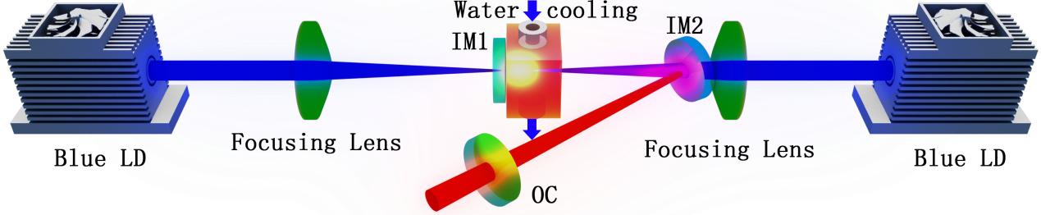

Fig. 1. Schematic diagram of the diode-double-end-pumped 642 nm Pr3+:CaF­­2 laser

**2. Results and discussion**

The output spectrum, registered by HR4000 Optical Spectrum Analyzer at the maximum pump power, is shown in Fig. 2. Laser oscillation corresponding to the 3P0->3F2 transition of Pr3+ at 642 nm was observed. No lasing at other wavelengths was observed. The peak lasing wavelength was measured to be 642.4 nm. The inset of Fig. 2 shows that the FWHM was measured to be 0.8 nm.

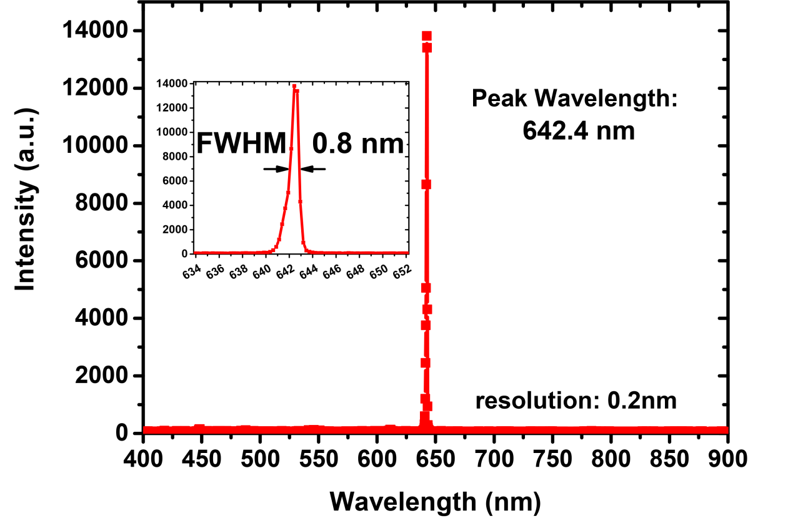

Fig. 2. Output spectrum of the Pr,Gd:CaF2 laser at 642 nm with a resolution of 0.2 nm. Inset shows the FWHM of output spectrum.

Experiments using output couplers with transmissions of 0.6%, 1.1%, 1.8%, 2.7%, 3.8% and 5.4% at 642 nm were carried out. Owing to the low gain of the laser crystal, the output coupler with a relatively low transmission of 1.8% achieved the highest output power and slop efficiency, compared with other robust Pr3+-doped fluoride crystals such as Pr3+:YLF. Fig. 3 shows the laser performance for our diode-double-end pumped Pr,Gd:CaF2 laser at 642 nm as obtained by using the output coupler with transmission 1.8%.

In the experiment, the left and right pump LDs were turned on in turn. Laser threshold was reached for an absorbed pump power of about 310 mW and a maximum output power of about 69 mW was achieved, leading to a total laser slope efficiency of 6.9% with respect to the absorbed pump power.

It is worth noting that when considered independently, the right pump source always exhibits a slight better performance than its left counterpart, i.e., lower threshold and higher laser power, notwithstanding switching their side. It may be attributed to the better overlapping factor between the pump and laser cavity modes for the converging pump beam (corresponds to the right pump source) than for the diverging pump beam (corresponds to the left pump source) as the focusing lens does not eliminate aberration so well for the blue pump beam.

Another notable feature for the laser performance is that given that the first pump source was already turned on, the second pump source would achieve an even better performance than just turn it on individually. That is to say, when both LDs were turned on at the same time, output power would be larger than the sum of each individually one. As is depicted in Fig. 3, the first pump source achieved a slop efficiency of 6.8% while the second one achieved a slop efficiency of 8.8% under conditions that the first pump source was tuned to maximum pump power. It may belong to the increased overlapping efficiency that the pump interacts with laser cavity modes when two pump beams were injected from both ends. To illustrate this clearly, we would like to introduce the concept, fractional thermal loading ξ, defined as the ratio of the thermal energy generated in the gain medium to the absorbed pump energy. It can be expressed as [30]

, (1)

where λl is the laser wavelength and λp is the pump wavelength, is the fractional of excited Pr3+ ions that involve the energy-transfer up-conversion (ETU) process, which can be written as

, (2)

Among which N0 is the initial population inversion and N is the population inversion. By virtue of employing diode-double-end pumped structure, the pump-to-mode size ratio decreases, and the fraction of excited ions involving ETU processes () is decreased. According to Eq. (1), the fractional thermal loading is also decreased, which means less thermal lensing effect, leading to a more efficient lasing. That could explain why the second half in Fig. 3 would achieve a higher slop efficiency than the first half.

The pause at an absorbed pump power of ~750 mw between the two pumping stage shown in Fig. 3 may result from bad beam quality of the pump source when the drive current is not large enough. As we can see, there is no sign of saturation even at high pump power, which means power scaling is still expected if higher pump power is injected.

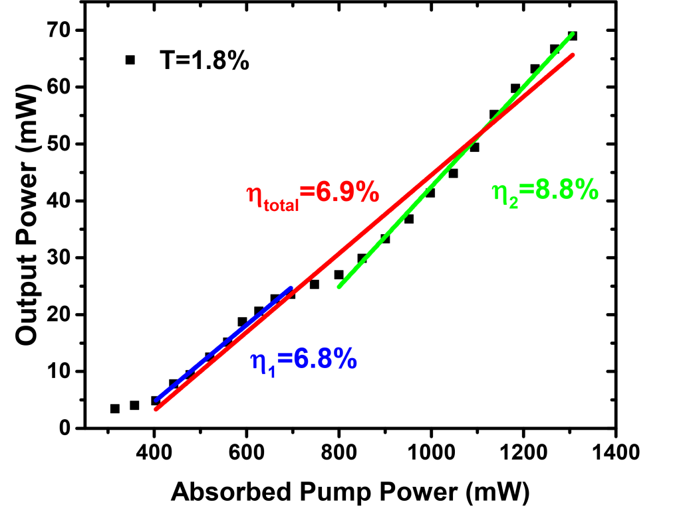

Fig. 3. Output power characteristics for diode-double-end pumped Pr,Gs:CaF2 laser at 642 nm with TOC=1.8%.

Fig. 4 shows the process of optimizing the transmissions of output coupler. The obtained slop efficiencies corresponding to transmissions of output coupler of 0.6%, 1.1%, 1.8%, 2.7%, 3.8% and 5.4% were 3.6%, 6.0%, 6.9%, 5.9%, 4.0% and 2.3%, respectively. As we can see, a decreased slop efficiency was observed when transmissions of output couplers exceed ~1.8% because losses began to prevail against gain beyond that point.

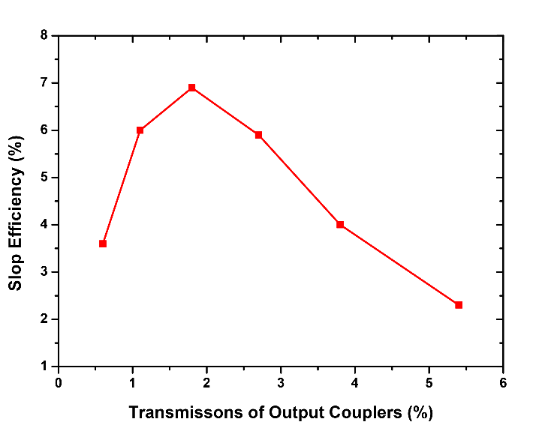

Fig. 4 Dependency of the slope efficiency on the output coupling transmission for continuous-wave Pr,Gd:CaF2 lasers operated at 642 nm.

To evaluate the beam qualities of the lasers, experiment with Spiricon Laser Beam Diagnostics system (M2-200) was conducted. The result is shown in Fig. 5. In fact, in a single-end-pumped structure, M2 factors were about 1.5. When double-end-pumped geometry was introduced, the M2 factor doubled with the doubling of output power. It is probable that the degraded beam quality was caused by thermal loading that results from the small volume of the pumping profile.

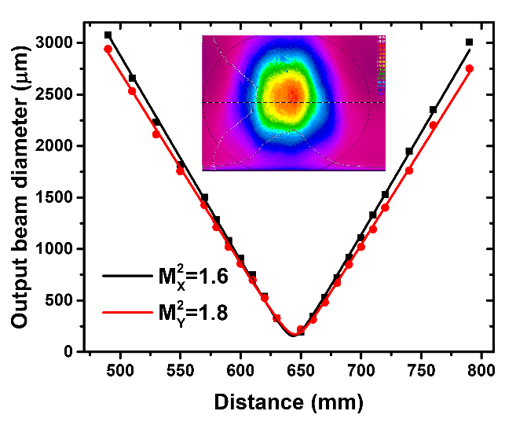

Fig. 5. Beam radius of the output laser as a function of the z axis location.

Testing to evaluate the stability of the 642 nm Pr,Gd:CaF2 laser at maximum pump power was also conducted for 30 min. As is depicted in Fig. 6, laser output was fairly stable and no obvious fluctuations were observed. The instability was less than 1%.

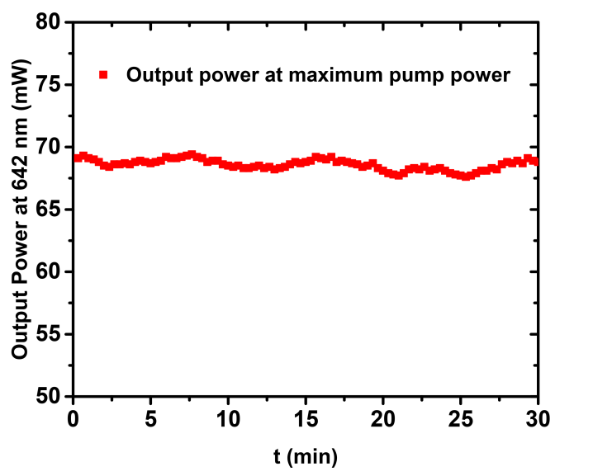

Fig. 6. Temporal behavior over 30 min of the 642 nm laser at maximum pump power.

**4. Conclusion**

In conclusion, this paper is the first demonstration of room temperature continuous-wave laser emission at 642 nm of Pr,Gd:CaF2 laser crystal as far as we know. With a diode-double-end pumped configuration, ~70mW output was obtained with a slop efficiency of 6.9% with respect to the absorbed pump power. The beam propagation factor M2 in the x and y direction was 3.2 and 3.6, respectively. Fluctuations at maximum output power were less than 1%. Besides, qualitative analysis was made to explain why double-end pumped configuration would be even more effective for lasing than single-end pumped structure if tuned properly.

As a prospect, power scaling of the Pr,Gd:CaF4 laser at 642 nm could be expected by utilizing more powerful pumping sources, such as a 5.3 W Coherent High Power OPS laser [31]. With a promoted output power, further works should be readily carried out, such as Q-switched or mode-locked laser operation with the aid of various saturable absorbers. In addition, new lasing wavelengths could be achieved for Pr,Gd:CaF2 laser crystal by using proper cavity mirrors.

**Acknowledgments**

The authors wish to acknowledge the financial support from the National Natural Science Foundation of China (61275050, 61605069), National key Research and Development Program of China (2016YFB0701002).

**References**

[1] A. Richter, E. Heumann, E. Osiac, G. Huber, W. Seelert, and A. Diening,“Diode pumping of a continuous-wave Pr3+-doped LiYF4 laser,” Opt. Lett., 29(2004) 2638.

[2] K. Hashimoto, and F. Kannari, “High-power GaN diode-pumped continuous wave Pr 3+-doped LiY F4 laser,” Opt. Lett. 32 (2007) 2493.

[3] T. Gün, P. Metz, and G. Huber, “Power scaling of laser diode pumped Pr3+:LiYF4 cw lasers: Efficient laser operation at 522.6 nm, 545.9 nm, 607.2 nm, and 639.5 nm,” Opt. Lett. 36(2011) 1002.

[4]

[6] F. Reichert, etal., “Diode pumped laser operation and spectroscopy of Pr3+:LaF3,” Opt. Express 20(2012) 20387.

[7] D. Paboeuf, O. Mhibik, F. Bretenaker, P. Goldner, D. Parisi, and M. Tonelli, “Diode-pumped Pr:BaY2F8 continuous-wave orange laser,” Opt. Lett., vol. 36, no. 2, pp. 280–282, Jan. 2011.

[8] P. Camy, J. L. Doualan, R. Moncorgé, J. Bengoechea, and U. Weichmann, “Diode-pumped Pr3+:KY3F10 red laser,” Opt. Lett., vol. 32, no. 11, pp. 1462–1464, Jun. 2007.

[9] B. Xu, et al., “Red and orange laser operation of Pr:KYF4 pumped by a Nd:YAG/LBO laser at 469.1nm and a InGaN laser diode at 444nm,” Opt. Express, vol. 21, no. 5, pp. 5567–5574, Mar. 2013.

[10] M. Fibrich, H. Jelinková, J. Šulc, K. Nejezchleb, and V. Škoda, “Visible CW laser emission GaN-diode pumped Pr:YAlO3 crystal,” Appl. Phys. B, vol. 97, no. 2, pp. 363–367, Aug. 2009.

[11] M. Fibrich and H. Jelínková, “Power-scaled Pr:YAlO3 laser at 747 and 720 nm wavelengths,” Laser Phys. Lett., vol. 10, no. 3, p. 035801, Jan. 2013.

[12] M. Fechner, F. Reichert, N.-O. Hansen, K. Petermann, and G. Huber,“Crystal growth, spectroscopy, and diode pumped laser performance of Pr,Mg:SrAl12O19,” Appl. Phys. B, vol. 102, no. 4, pp. 731–735, Feb. 2011.

[13] F. Reichert, D.-T. Marzahl, P. Metz, M. Fechner, N.-O. Hansen, and G. Huber, “Efficient laser operation of Pr3+,Mg2+:SrAl12O19,” Opt. Lett., vol. 37, no. 23, pp. 4889–4891, Dec. 2012.

[14] Dressler L, rauch R, Reimann R,“On the inhomogeneity of refractive index of CaF2 crystals for high performance optics,” Crystal Research Technology, 23, 413-420(1992)

[15] P. Camy, J.L. Doualan, A. Benayad, M. Von Edlinger, V. Menard, R. Moncorge, “Comparative spectroscopic and laser properties of Yb3+-doped CaF2, SrF2 and BaF2 single crystals,” Appl. Phys. B 89, 539 (2007)

[16] J. Tu, S.A. FitzGerald, J.A. Campbell, A.J. Sievers, J. Non-cryst. Solids 203 (1996) 153.

[17] P.P. Sorokin, M.J. Stevenson, Phys. Rev. Lett. 5 (1960) 557.

[18] G.D. Boyd, R.J. Collins, S.P.S. Porto, et al., Phys. Rev. Lett. 8 (1962) 269.

[19] S. E. Hatch, W. F. Parsons, and R. J. Weagley, Appl. Phys. Lett. 5, 153 (1964).

[20] J. Lu, J. F. Bisson, K. Takaichi, T. Uematsu, A. Shirakawa, M. Musha, K. Ueda, H. Yagi, T. Yanagitani, and A. A. Kaminskii, Appl. Phys. Lett. 83, 1101 (2003).

[21] A. Lucca, M. Jacquemet, F. Druon, F. Balembois, and P. Georges, P. Camy, J. L. Doualan, and R. Moncorgé, “High-power tunable diode-pumped Yb3+:CaF2 laser”, Optics Letters · September 2004.

[22] Mathias Siebold, Marco Hornung, Ragnar Boedefeld, Sebastian Podleska, Sandro Klingebiel, Christoph Wandt, Ferenc Krausz, Stefan Karsch, Reinhard Uecker, Axel Jochmann, Joachim Hein, and Malte Christoph Kaluza, "Terawatt diode-pumped Yb:CaF2 laser," Opt. Lett. 33, 2770-2772 (2009)

[23] Alexander Kessler, Marco Hornung, Sebastian Keppler, Frank Schorcht, Marco Hellwing, Hartmut Liebetrau, Jörg Körner, Alexander Sävert, Mathias Siebold, Matthias Schnepp, Joachim Hein, and Malte C. Kaluza, "16.6 J chirped femtosecond laser pulses from a diode-pumped Yb:CaF2 amplifier," Opt. Lett. 39, 1333-1336 (2014)

[24] F. Friebel,1,* F. Druon,1 J. Boudeile,1 D. N. Papadopoulos,1 M. Hanna,1 P. Georges,1 P. Camy,2 J. L. Doualan,2 A. Benayad,2 R. Moncorgé,2 C. Cassagne,3 and G. Boudebs3, “Diode-pumped 99 fs Yb:CaF2 oscillator”, OPTICS LETTERS / Vol. 34, No. 9 / May 1, 2009

[25] Z. P. Qin, G. Q. Xie, J. Ma, W. Y. Ge, P. Yuan, L. J. Qian, L. B. Su, D. P. Jiang, F. K. Ma, Q. Zhang, Y. X. Cao,and J. Xu, “Generation of 103 fs mode-locked pulses by a gain linewidth-variable Nd,Y:CaF2 disorderedcrystal,” Opt. Lett. 39(7), 1737–1739 (2014)

[26] V.P. Bhola, “Optical study of CaF2 : Pr3+,” Journal of Luminescence 10(1975) 185.

[27] D.R. Tallant, M.P. Miller, J.C. Wright, J. Chem. Phys. 65 (1976) 510.

[28] Xu Bin, Liu Zhe, Xu Huiying, Cai Zhiping, Zeng Chenghang, Huang Shunlin, et al. “High-efficiency InGaN-LD-pumpedbulkPr:YLForangelaserat607nm,” Opt Commun2013;305:96–9.

[29] Paboeuf David, Mhibik Oussama, Bretenaker Fabien, Goldner Philippe, Parisi Daniela, TonelliMauro, “Diode-pumpedPr:BaY2F8 continuous-waveorange laser,” OptLett2011;36(2):280.

[30] Y. F. Chen, “Pump-to-mode size ratio dependence of thermal loading in diode-end-pumped solid-state lasers,” J. Opt. Soc. Am. B 17(2000) 1835.

[31] V. Ostroumov, W. Seelert, and L. Hunziker, “522/261 nm cw generation of Pr:YLF laser pumped by OPS laser,” Proc. SPIE, 6451(2007) Art. ID. 451046.